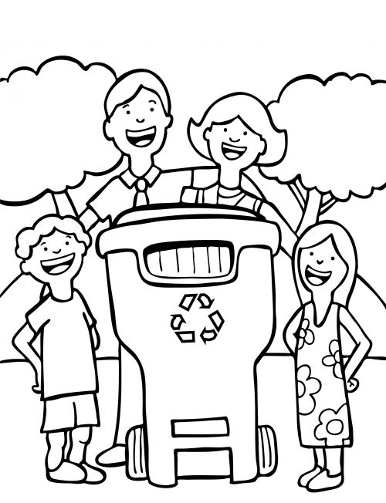

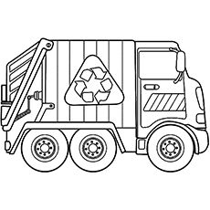





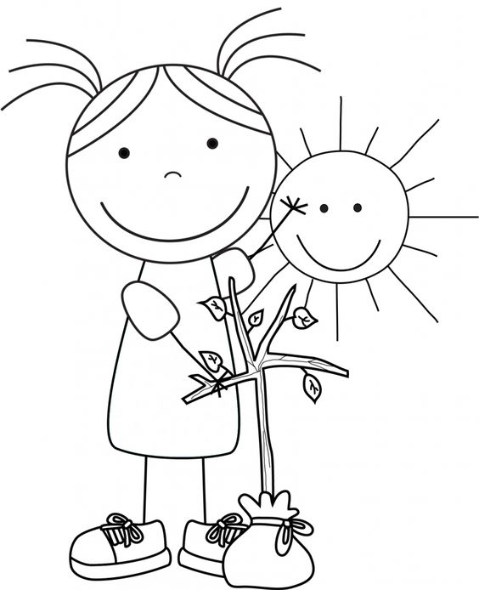

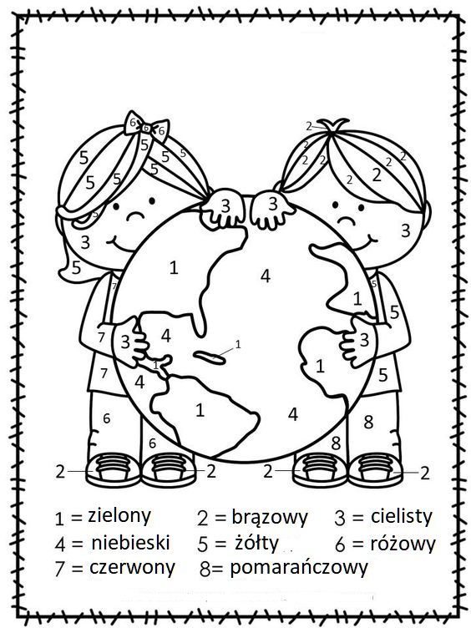

[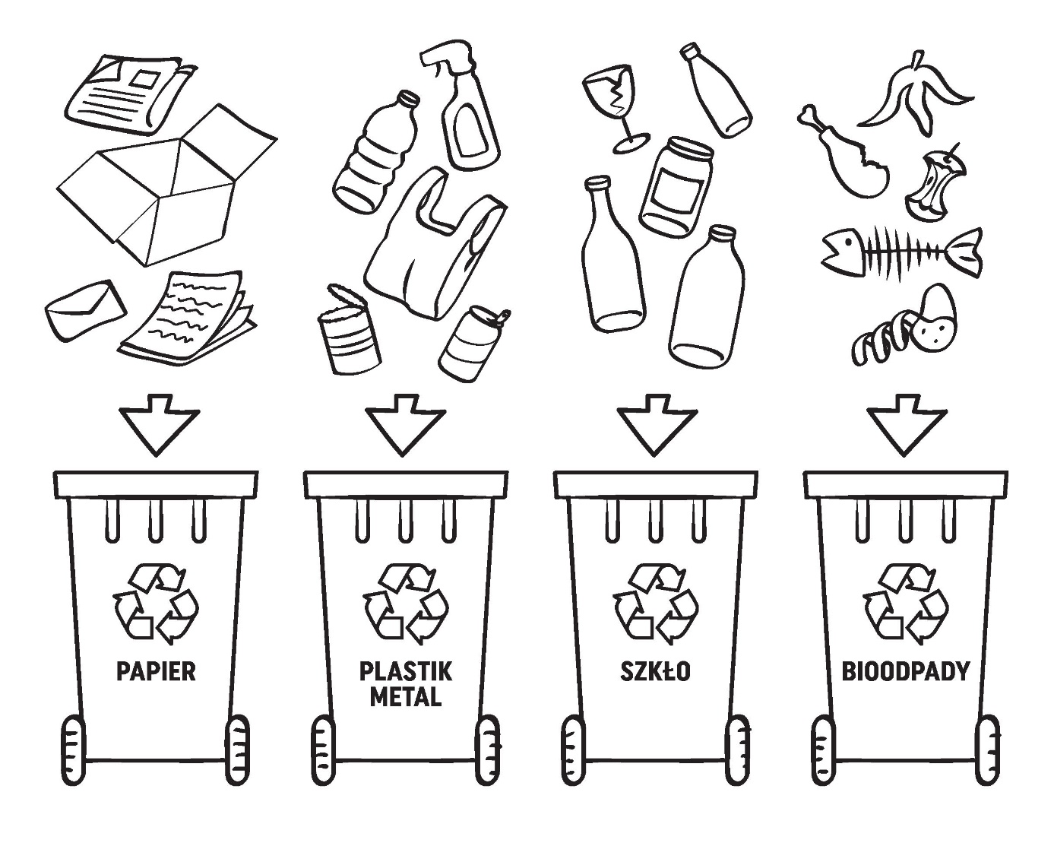](https://www.google.pl/url?sa=i&url=https%3A%2F%2Fnaklejkastrona.blogspot.com%2F2019%2F04%2Fnowy-smieci-kolorowanka.html%3Fn%3D5&psig=AOvVaw2RVXS9Rfw0E07p9J2mAz6x&ust=1587599188901000&source=images&cd=vfe&ved=0CAIQjRxqFwoTCJCr0YDa-ugCFQAAAAAdAAAAABAD)

